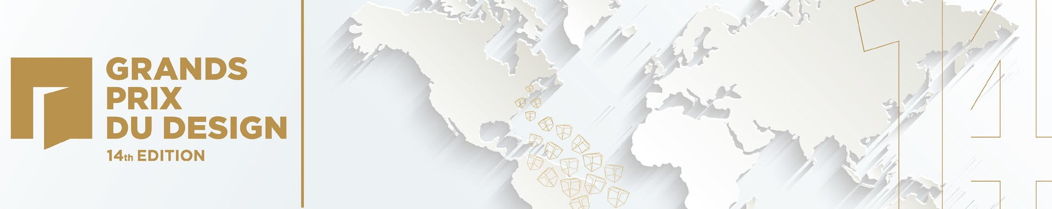

The GRANDS PRIX DU DESIGN Awards
Launches a First-Ever Worldwide Call-for-Entries for Its 14th Edition!

Montréal, September 25, 2020 – The prestigious and respected GRANDS PRIX DU DESIGN Awards announces the official opening of its call-for- entries, open for the first time ever to candidates worldwide!

A STORY THAT KEEPS GROWING
From Québec to the International!
Created in 2007 in Montréal, with the mission of recognizing the excellence of Québec designers and architects having distinguished themselves through an exemplary practice, the competition was originally open exclusively to firms and professionals operating a place of business in Québec. For its 14th edition, the GRANDS PRIX DU DESIGN Awards opens its call-for-entries to candidates worldwide.

STARTING IN 2020!
In addition to becoming a worldwide competition in which all categories are open for submissions from Québec, Canada and the world, the GRANDS PRIX DU DESIGN adds new disciplines.

The disciplines of the 14th edition:
Architecture ■ Interior Design ■ Construction and Real Estate Development ■ Industrial Design and Product Design ■
Brand Design ■ Urban Design, Landscape Architecture and Landscaping
Design and architecture professionals and students, as well as to real estate developers, contractors, manufacturers, and clients who have called upon these professionals are inviting to present their projects and products to an International Jury.
Some 70 leading professionals, prominent academics and influential press members, recruited on an international scale, will use their knowledge and experiences to evaluate the excellence of submitted projects and products.

A GREAT OPPORTUNITY
An award granted by the prestigious GRANDS PRIX DU DESIGN Awards is a stamp of excellence and an international reference. The impressive list of laureates awarded in the first 13 editions of the contest is comprised of young up-and-coming studios as well as leading firms, responsible for emblematic projects and products recognized worldwide. Regardless of your status, professional or student, your career stage or the size of your team, the contest leads to international recognition and promotion opportunities for its candidates, finalists and winners.
Contest participants will enhance their brand recognition and reach new press coverage and market opportunities. An international visibility will be given to all participants on the INT.design portal, an online content platform aimed at promoting excellence in design, architecture and built environment.
Being granted a GRANDS PRIX DU DESIGN Award reinforces brand recognition, attracts the best talents and gives clients and prospects a confidence boost sometimes helpful in deciding to invest in a professional or firm’s services.

CALENDAR
› Submissions are welcome online on the INT.design portal in the section: Contests/GRANDS PRIX DU DESIGN
- Early entry rate until October 15, 2020
- Regular rate until November 15, 2020
- Final rate until December 15, 2020
› Digital files must be uploaded online by December 15th, 2020, at the latest.
› The International Jury deliberation will determine Gold, Silver and Bronze finalists announced online in February 2021.
› Gold laureates become finalists, eligible for Platinum awards (1 per category), for Top50 Québec and International awards and for Awards of the Year (1 per discipline), announced live on stage at one of the two Gala evenings, held in Québec City in April 2021 and in Montréal in June 2021.

Video ■ Candidate Kit ■ International Jury ■ Promotional materials

ABOUT
GRANDS PRIX DU DESIGN
Created in Montreal, UNESCO city of design, in 2007 and organized by PID Agency, the GRANDS PRIX DU DESIGN Awards celebrates the work of creators who enhance the quality of our lives and of the built environment, as well as the public and private clients who entrusted them with their needs. Fostering the notion of appreciation and promotion of a quality design, the contest ensures professional recognition and international visibility to its participants. After 13 editions reserved to professionals with a place of business in Québec, the contest opens entirely to the world as of 2020 and adds new disciplines complementary to design, architecture and landscape. All categories are now open to candidates from Québec, Canada and the world.

PID Agency
A design and architecture industry media firm established for over 30 years, PID Agency is known for its local, national and international expertise. Its main platforms are praised for their creativity and for the way in which they serve their purpose: promoting excellence in design and architecture.

INFORMATION: INT.design/Contests/GRANDS PRIX DU DESIGN
Media Contact Mariève-Patricia Langevin 450-651-3630 ext. 236
mp.langevin@agencepid.com

Awards of the Year

13th edition
Strøm Spa Nordique Vieux-Québec
Design : LEMAYMICHAUD Architecture Design
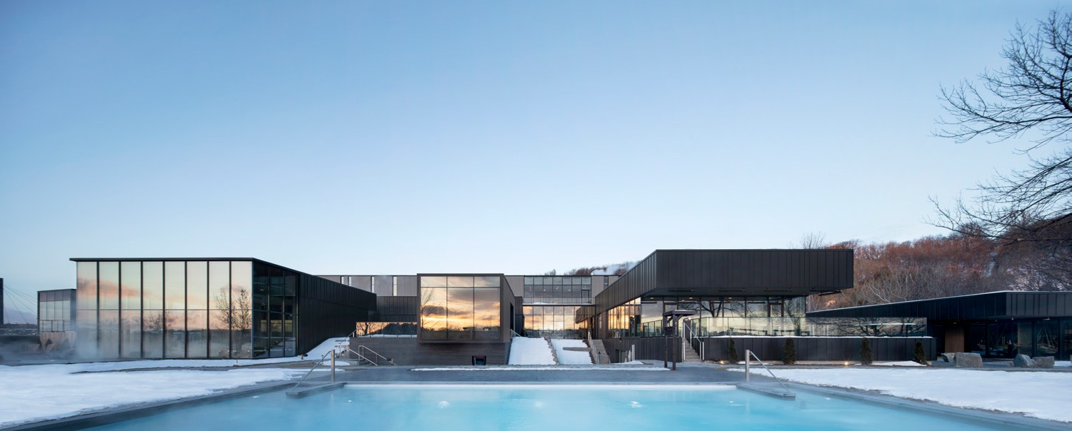
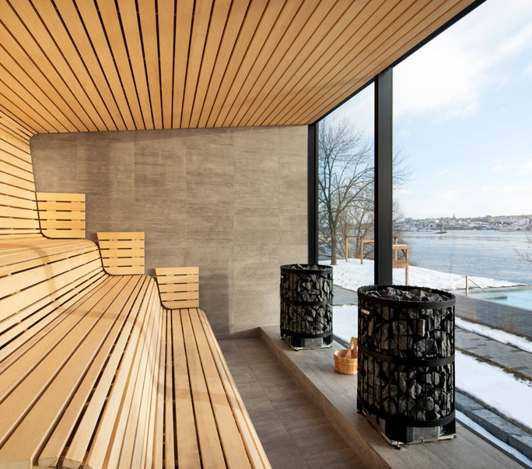

12th edition
Conversion du Planétarium Dow de l’ÉTS
Design : MENKÈS SHOONER DAGENAIS LE TOURNEUX Architectes
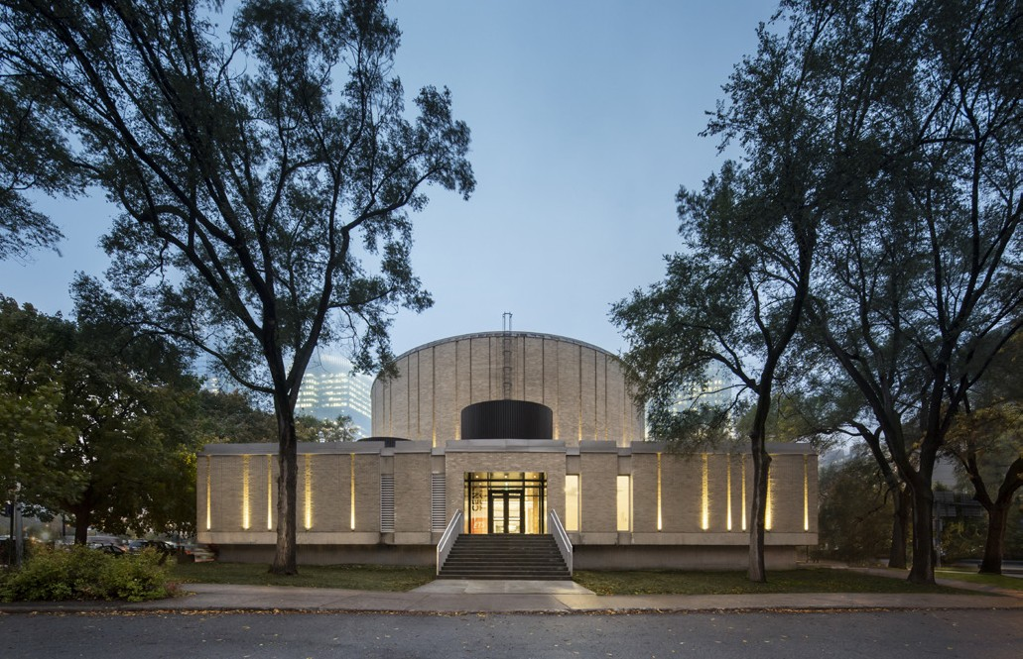
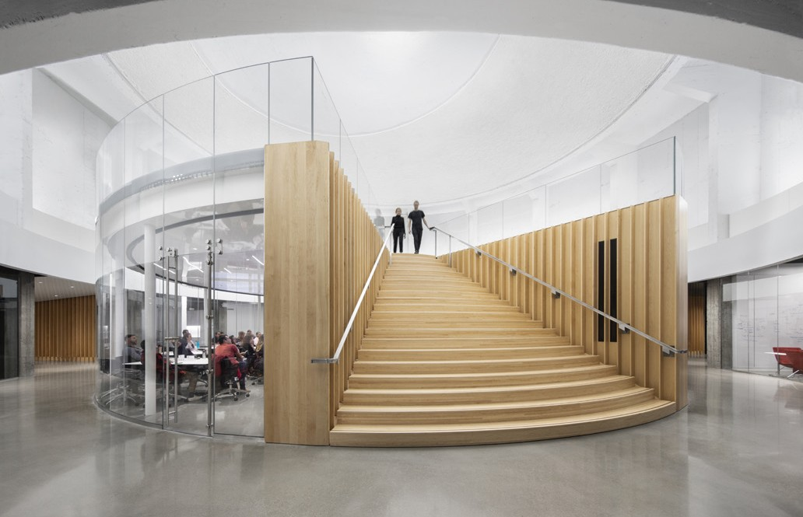

11th edition
Centre hospitalier de l’Université de Montréal Design: CannonDesign + NEUF architect(e)s
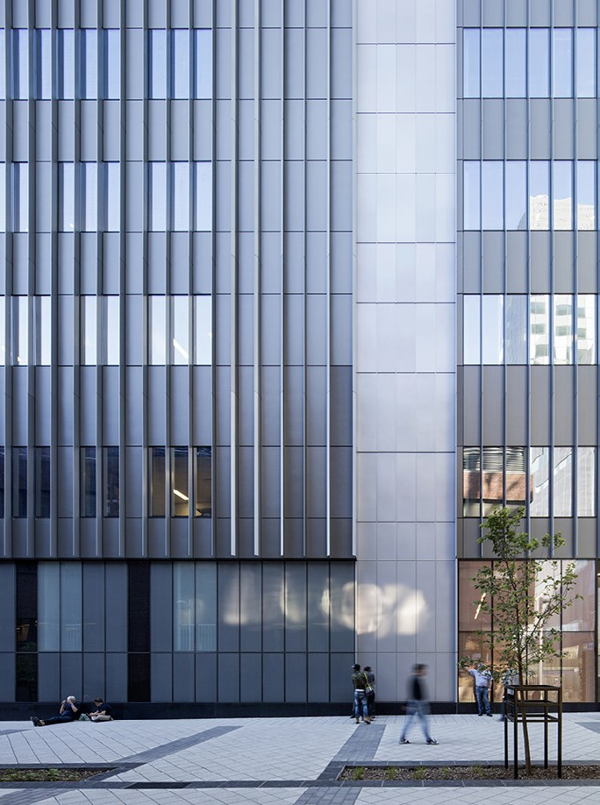
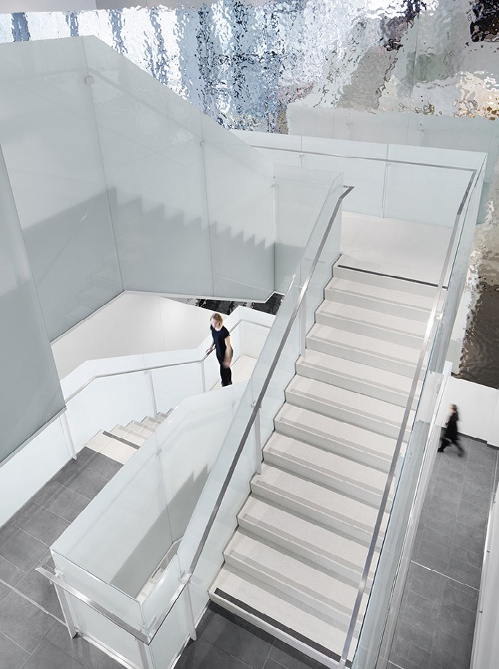

10th edition
Crew Collectif et Café
Design : Henri Cleinge, architecte
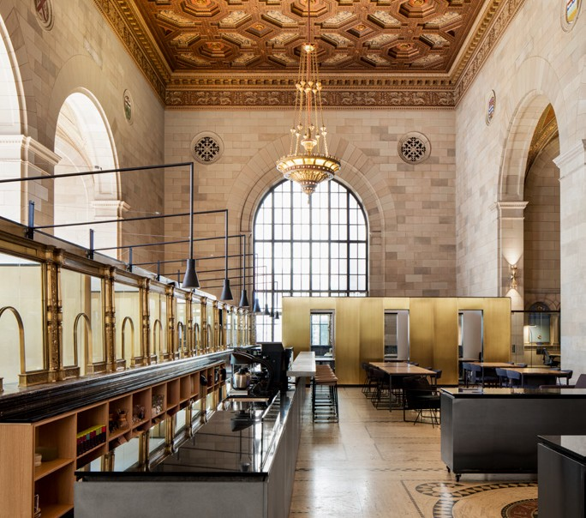
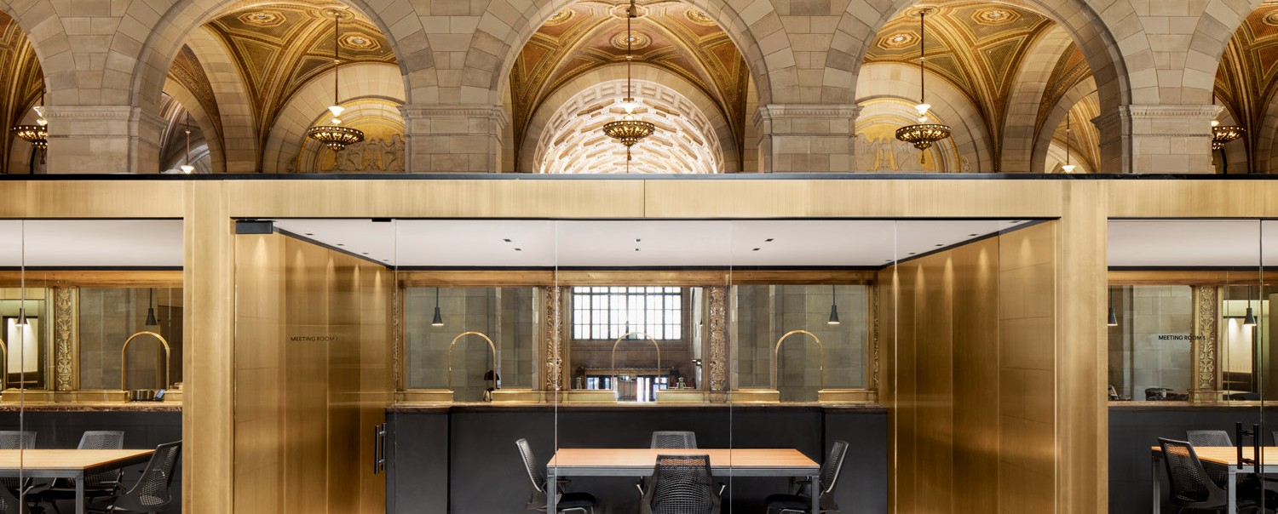

9th edition
Académie Sainte-Anne Design : Taktik design
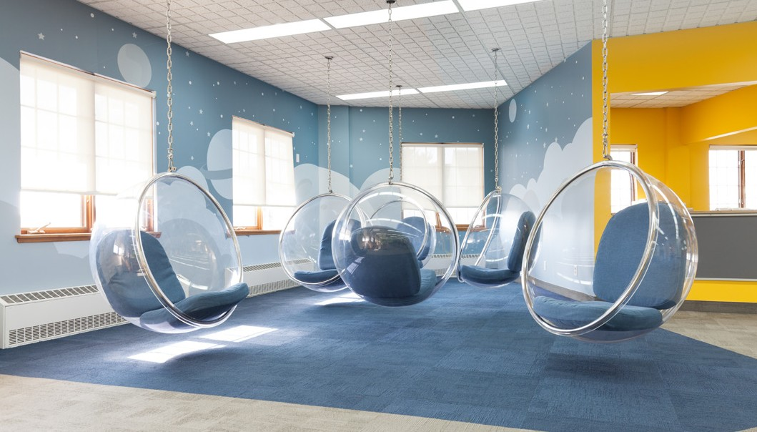
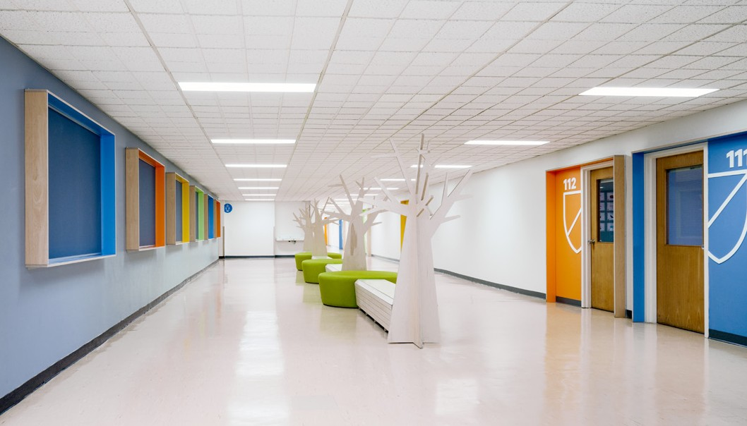

8th edition
Le Casino de Montréal
Design : Menkès, Shooner, Dagenais, LeTourneux / Provencher_Roy / MOUREAUX HAUSPY+ASSOCIÉS / BLAZYSGERARD
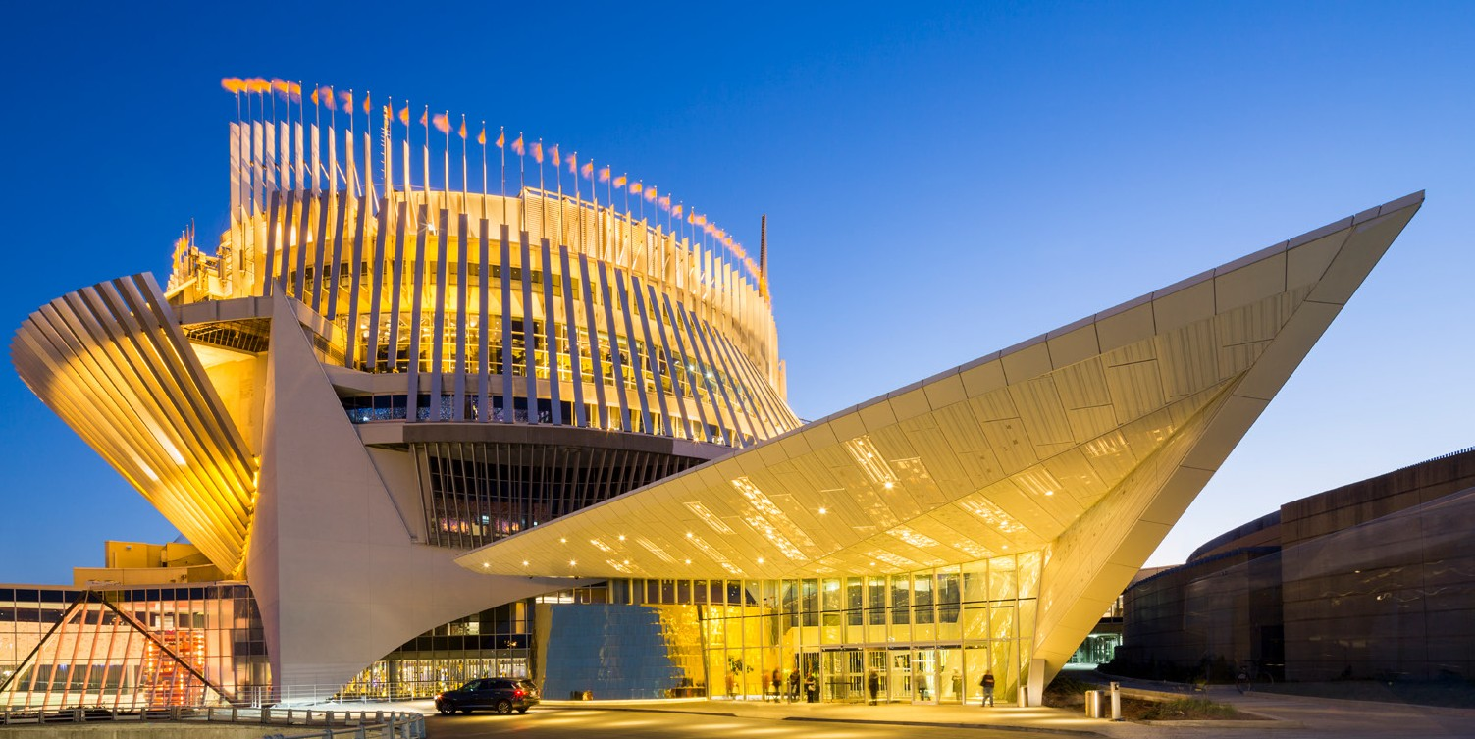
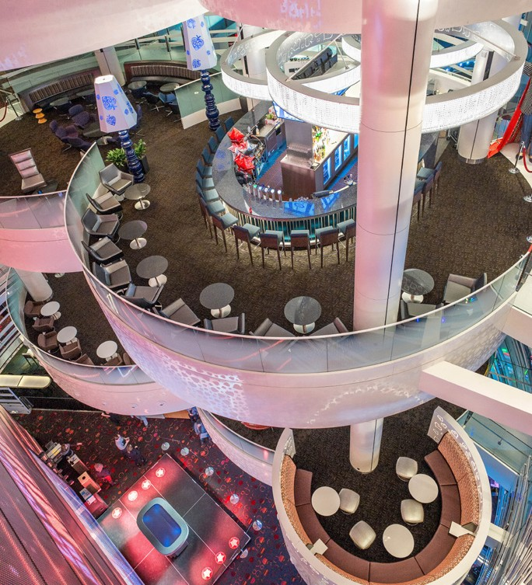

7th edition
Allez-Up centre d’escalade
Design : Smith Vigeant architectes
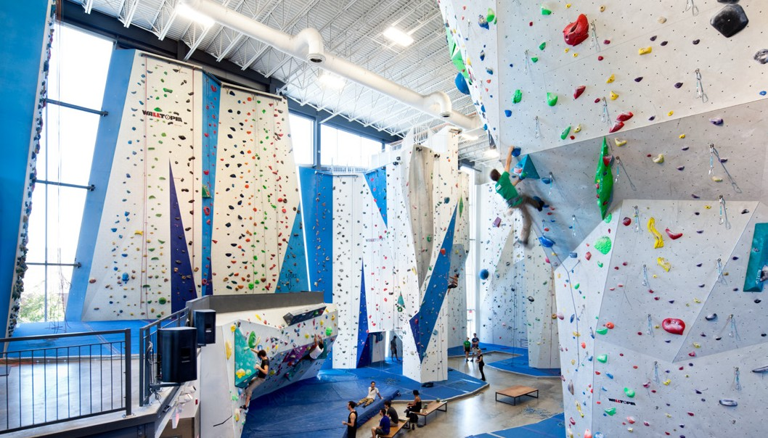
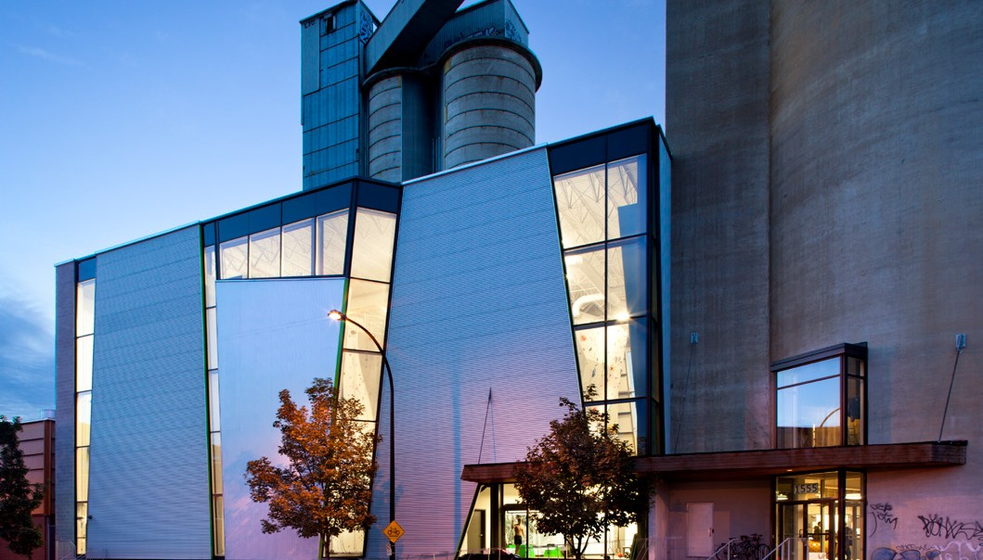

6th edition
Place des Arts
Design : Sid Lee Architecture + Ædifica
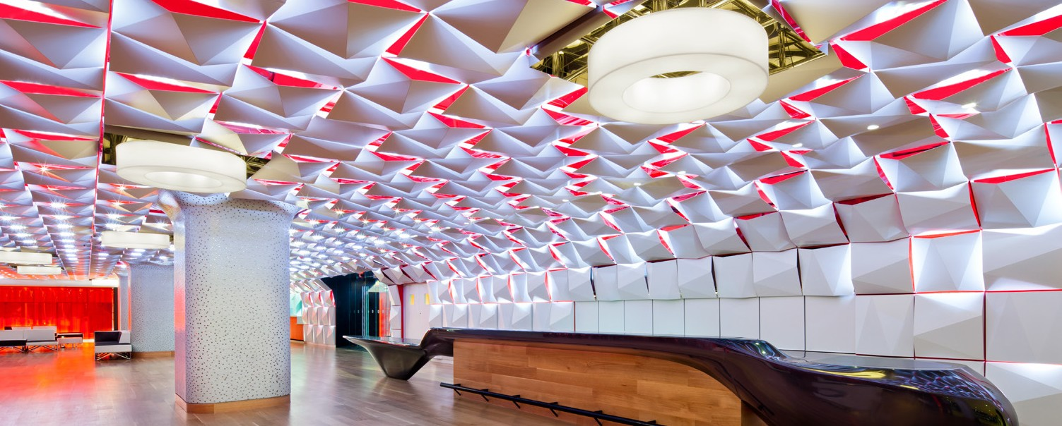
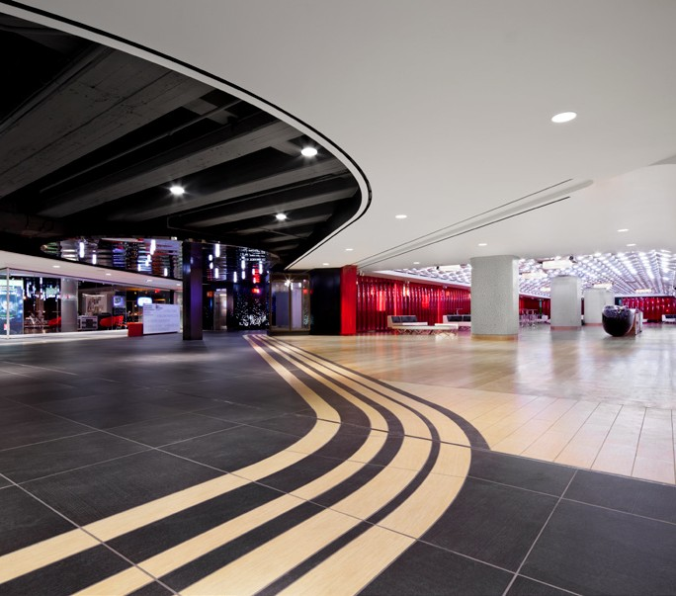

5th edition
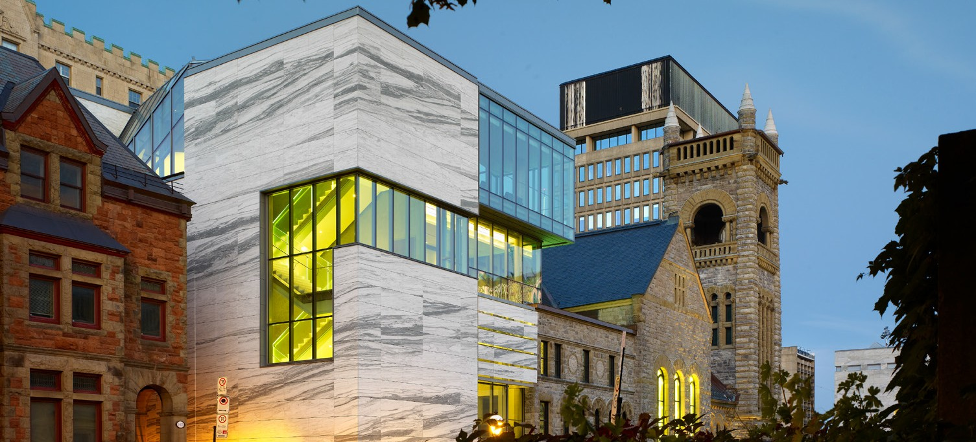
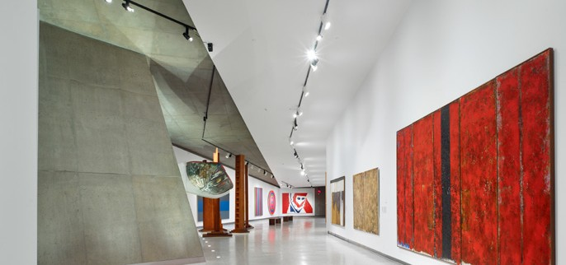
MBAM_Pavillon d’art québécois et canadien Claire et Marc Bourgie Design : Provencher_Roy + Associés Architectes

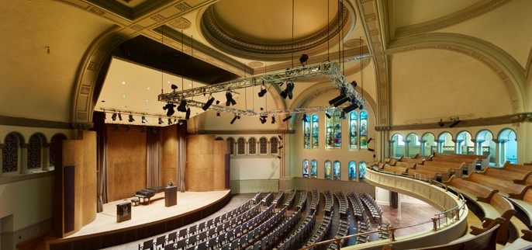
4th edition
BOTA BOTA
Design : Sid Lee Architecture
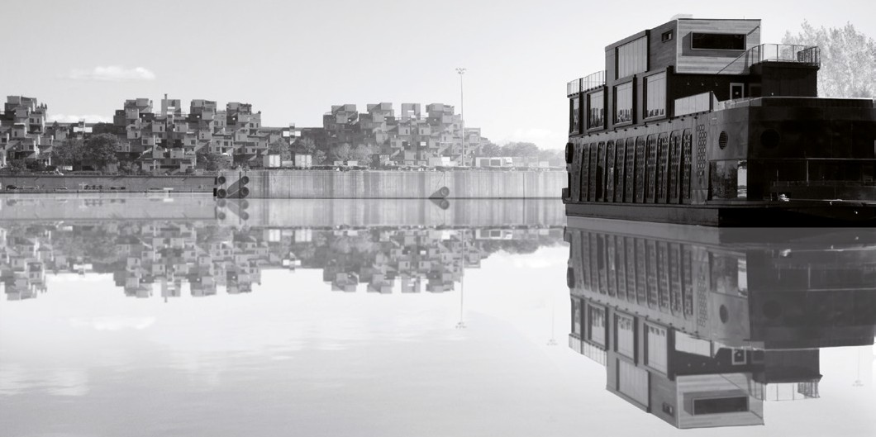
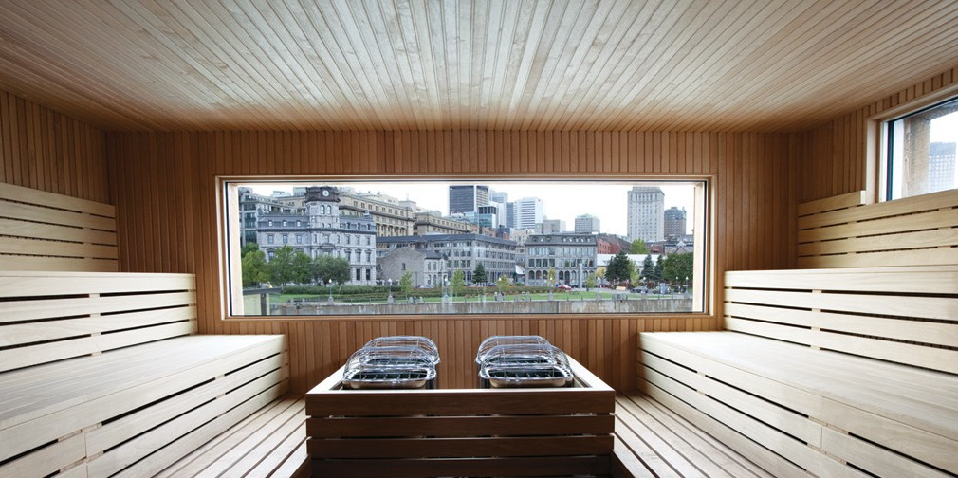

3th edition
Scandinave les bains
Design : Saucier + Perrotte Architectes
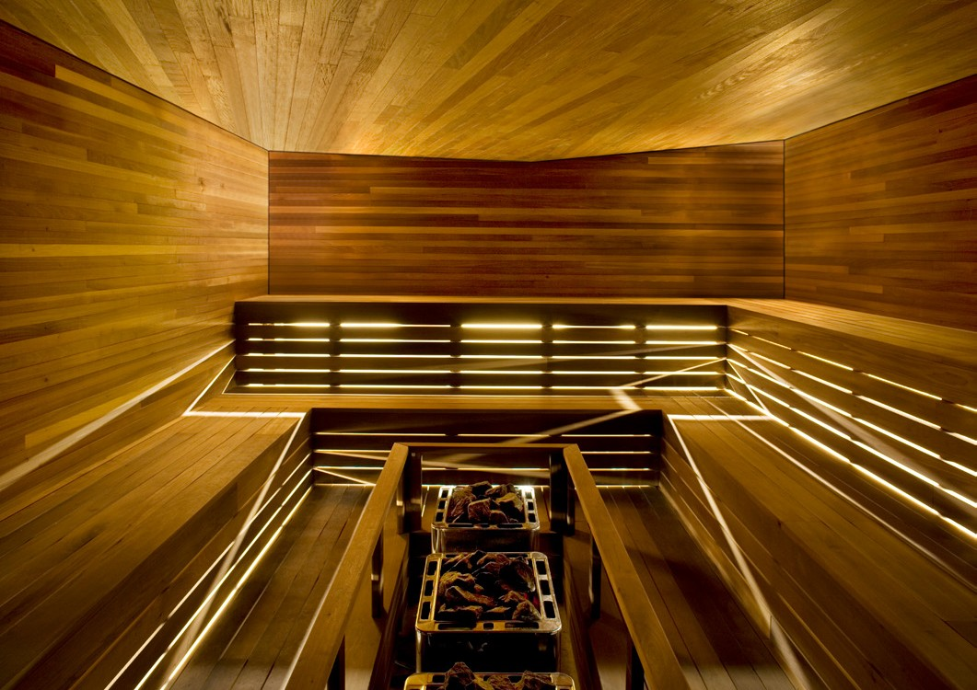
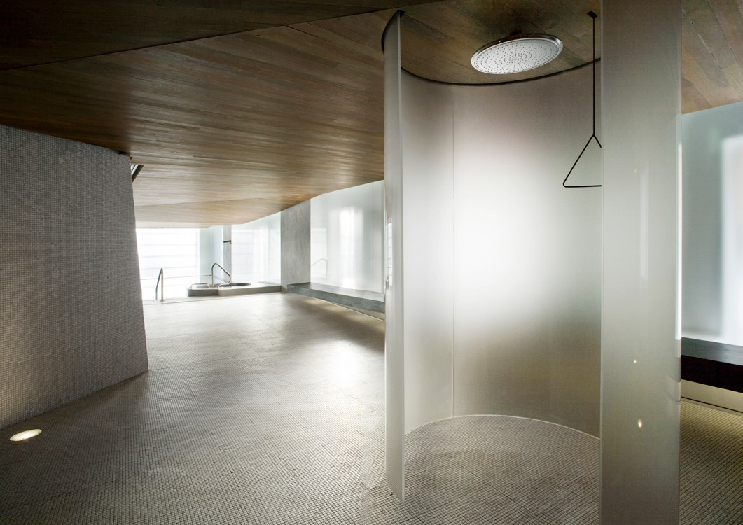

2th edition
Gray Projet
Design : Borrallo Interiors
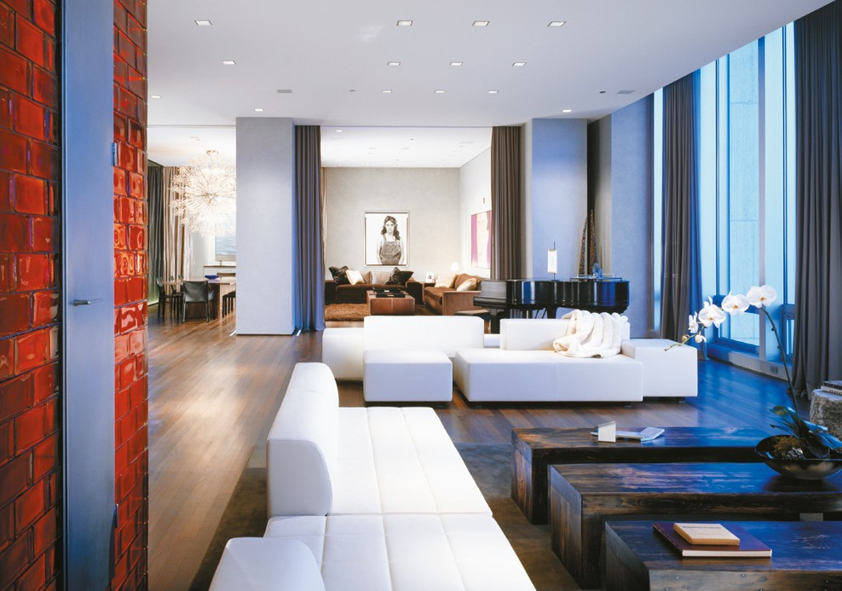
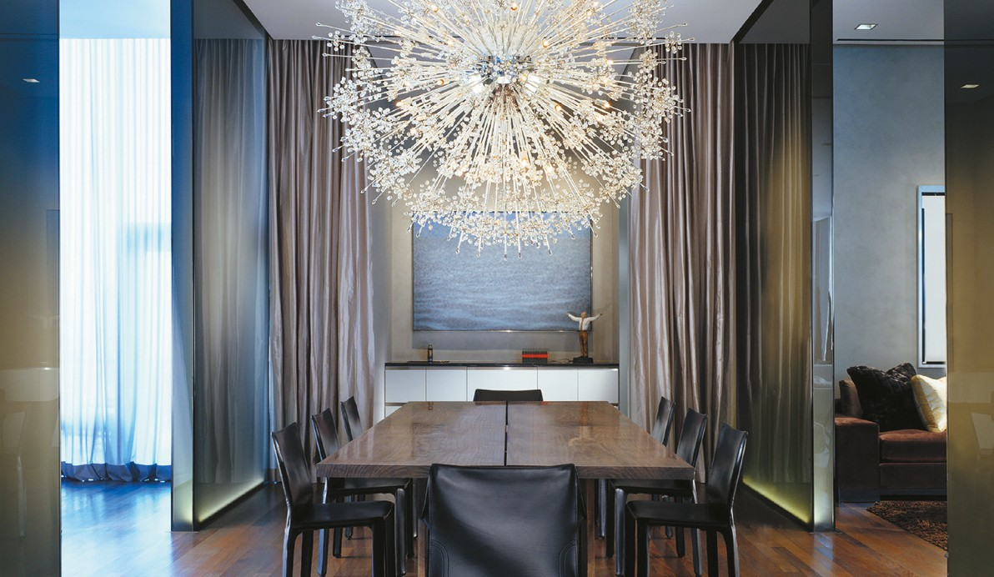

1st edition
Workshop Architecture+Design Design : Sid Lee Architecture
